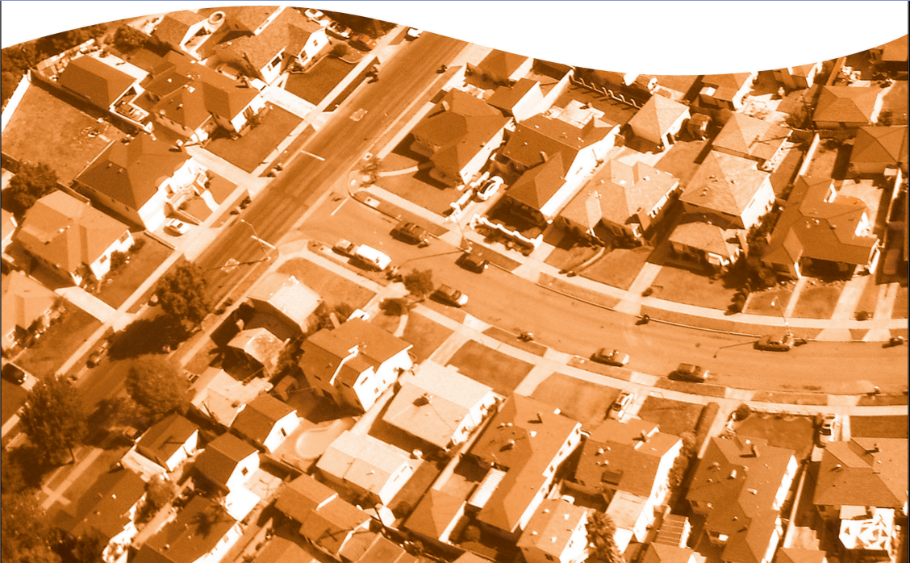

ITV Capture™

INSPECTION REPORT

Insured’s Copy

**InspekTech®**  
#401, 800-15355-24th Ave,  
Surrey, British Columbia V4A 2H9

www.InspekTech.com





**WE RECOMMEND AGAINST SENDING THIS REPORT   
TO YOUR CLIENT.**

*This ITV Capture™ report is intended for Insurance Underwriters, Agents, Brokers and other trained insurance Professionals. We recommend against providing this full unabridged report to your clients as untrained readers may misinterpret industry   
concepts, leading to possible push-back.*

*We supply every ITV Capture™ report with a* ***Client Copy*** *whose data is unchanged, though the format and some inclusions are abridged. Also, included are commonly raised issues plainly addressed to avoid potential push-back if read and understood by the insured.*

**If your client asks for a copy, provide them the   
Client Copy**by logging into the file. Then, simply   
download it instantly.

**ITV Capture™**



replacement value inspection report

www.InspekTech.com

**test1Fname test1Fname, test2Fname test2Fname**

**401, 401, 1535 Best Ave, Test Street Testcity, BC M4B 1B3  
Replacement Cost: $Value Insert**



SUMMARY REPORT

Date of Site Visit: **n/a**

Policy No: testPolicy1234567890

Customer No: 111

InspekTech ID: 4153933   
Insured: test1Fname test1Fname, test2Fname test2Fname  
Site Contact: test1Fname test1Lname

____________________________________________________

COMPANY/BROKER

Company: ACTIVE EARTH ENGINEERING LTD.

Requester: MITCHELL, DAVID (P)

**IMPORTANT NOTE TO READER: InspekTech®** does not purport to list all hazards and will not be responsible to the Customer for any loss or damage, consequential or otherwise, however caused, incurred or suffered, as a result of the services being provided. This observation report is based on information obtained at the time of the survey, code information when and where available, and principles and practices that can or may be considered as industry standard. The ITV value provided will be developed utilizing the power of **CoreLogic® Residential Component Technology (RCT)** and any other CoreLogic tools to provide a building replacement value for the subject dwelling based on a non-measured inventory of exterior and interior components and features. The estimated size of the dwelling has been taken from property taxation or similar records and has not been verified. The value provided is an estimate only, as based on standardized regional data for the dwelling type.

REPLACEMENT COST SUMMARY

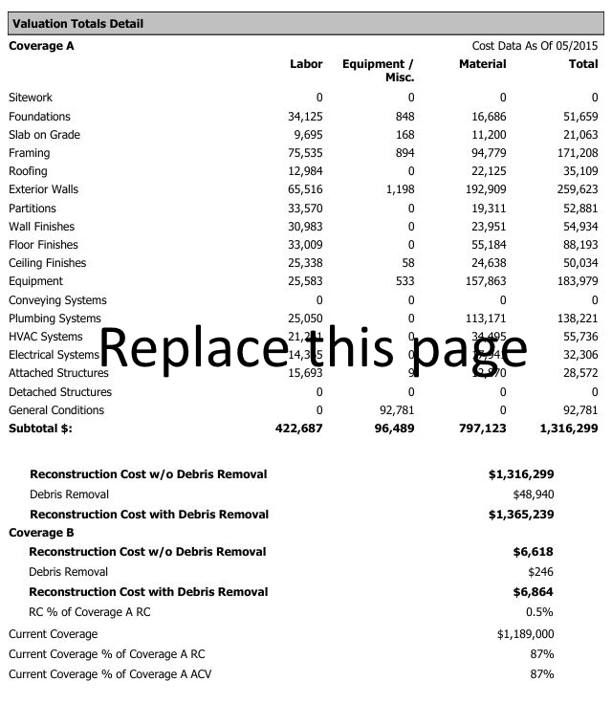

|  |  |  |  |  |  |
| --- | --- | --- | --- | --- | --- |
| Building Data | | | | | Building Photos |
| Year Built: 2020 | | | Building Style: 1 Story; 2 Story | |  |
| Type of Construction: | | | Standard | |
| Foundation Types: | | | Slab at GradeSlab at Grade, 45% | |
| Foundation Materials: | | | Block | |
| Foundation Conditions: | | | n/a | |
| (i) Total Building Area * | | | 4 | |
| (ii) Finished Living Area (FLA) * | | | 2 | |
| (iii) Total Living Area (TLA) * | | | 3 | |
| Exterior Condition Summary | | | | |
| Exterior Wall Conditions: | | | n/a | |
| Roof Surface Conditions: | | | n/a | |
| Approximate Roof Age: | | n/a | n/a years | |
| Exterior Features | | |  | |
| 800 sqft | Built-in Garage, sq.ft | | 3 | Door, Hollow Core, Birch |
| Array |  | | 40% | Sash, Vinyl with Glass |
| Array |  | | 0 |  |
| 40% | Sash, Vinyl with Glass | | 45 sqft | Door, French, sq.ft |
| General Exterior Comments: This is a test general comments | | | | |
| Interior Condition Summary | | | | |
| Condition of Walls/Floors/Ceilings | | | Excellent Maint. w/high value finishes | |
| Interior Features | | | **Kitchen(s)** | |
| Central Burglar Alarm System | | | Semi-Custom 2; Custom 2 | |
| Steam Shower, Complete | | |
| n/a | | | **Bathroom(s)** | |
| n/a | | | Full Bath, Semi-Custom 3; 1/2 Bath, Semi-Custom 1; 3/4 Bath, Semi-Custom 2 | |
| n/a | | |
| Filtration System, Water Softener | | |
| General Interior Comments: This is a test general public comments | | | | |
| Liability Observations | | | | |
| Handrails: | | | In place/secure (Good condition) | |
| Guardrails: | | | Missing in one or more places | |
| Surface Conditions: | | | Average conditions, no concerns | |
| Pools & Hot tubs: | | | Pool area fenced | |
| Pets: | | | Large dog, appears unfriendly | |
| Exposures / Other Items: | | | This is a test exposure/other items public comments | |

*

***(i)******Total Building Area*** *is the total sq.ft within the building.* ***(ii) Finished Living Area (FLA)*** *is the sq. ft. measurement of the main living area but does not include the basement area (even if finished), any garage type, or lower level unfinished areas in the Finished Living Area (FLA). Any finished features in basement areas (including special rooms, kitchens, bathrooms, etc.) are valued and included in the home's inventory. Standard and custom finishing in basement areas are accounted for and integrated in the development of the replacement value of this report****. (iii) Total Living Area (TLA)*** *is the FLA plus any Built-in Garage space. This measurement reporting method is standard to the insurance industry. Sq. Ft measurements in this report may be approximate to within reasonable range for underwriting purposes.*

BUILDING

BUILDING MATERIALS SUMMARY

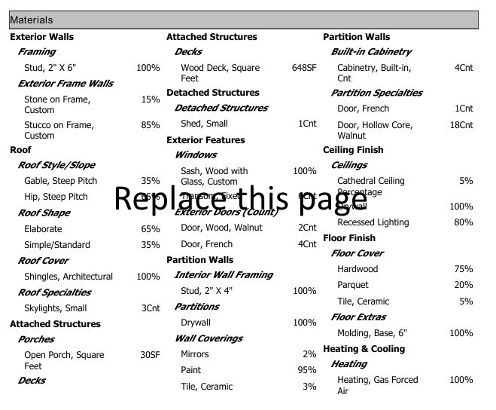

BUILDING MATERIALS SUMMARY *(Continued)*

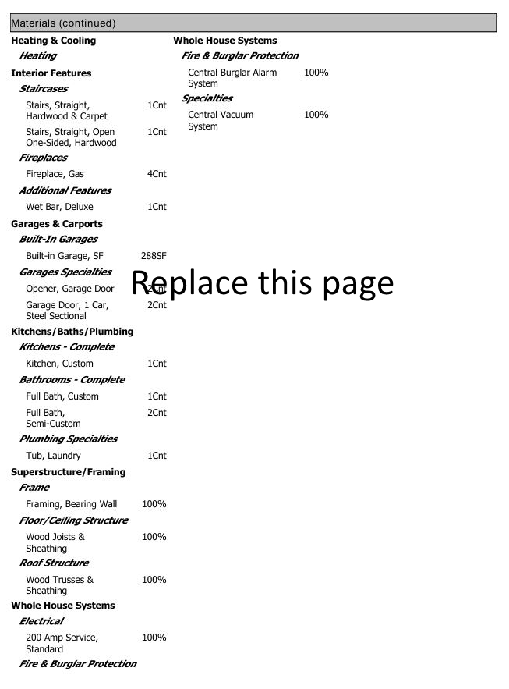

GENERAL SERVICES & SECURITY/ LIFE SAFETY/PROTECTION

|  |  |  |
| --- | --- | --- |
| Common Services for Dwelling | | Detached Structures & Features |
| electircal Service Type | Overhead | This is a test public detached comment |
| Electrical Service Panel(s) | Unable to locate or blocked from viewing |
| Clearance Concerns | Minor tree/ shrub blockage - Must have photo(s)!! |
| Elec. Service Rating | 200 Amp Service, Standard | Common Services & utitlity comments |
| Wiring Type | Mixed: Copper/Conduit | This is a test of common service and utility comments |
| Elec. Services Condition | Good, upgrades evident |
| Heating Type | Heating, Gas Forced Air (Furnace) |
| A/C /Heat Pump: | n/a |
| HVAC Equipment Condition | Equipment in Good condition |
| Solid Fuel Appliances | No Solid Fuel units | utitlity PHOTOS |
| Fireplaces | n/a |  |
| Water Source | Private well |
| Water Supply Piping | Copper pipe |
| Waste Line Piping | ABS Plastic |
| Sewer service type | Public Sewers |
| Plumbing Conditions | Good, no concerns observed |
| Hot Water Tank | n/a |
| Hot Water Tank Age & Condition | 4 yr, Average condition |
| Clothes Washer Hoses | Rubber Hose, Good Condition |
| Dryer Venting | Unable to confirm |
| Security/protection services | |
| Security Alarm System | Monitored Alarm |
| Alarm Coverage Area | Interior of dwelling |
| Company Signage | Lawn sign(s) |
| Surveilance Systems | Cameras all corners |
| Exterior Lighiting | n/a |
| Exterior Door Locks | Mixed: Deadbolts + Sliding Door Locks |
| Fire Sprinkler System | Furnace/Boiler room Coverage only |
| Smoke Detectors | 1 or more Hard Wired unit(s) |
| co Detectors | 2+ Hard Wired Units |
| Fire Extingushers | Insured plans on buying a new one |
| Hydrant Protection | Yes, fire hydrants in area |
| Distance to Hydrant | More than 8 km |
| Fire Protection Service | Paid |
| Distance to fire Hall | More than 8 km |



RECOMMENDATIONS at the time of the survey the conditions below were found. the recommendations to correct:

**1**

* Comment on condition goes here.
* Recommendation goes here.

Explain here…



**IMPORTANT NOTE TO READER: InspekTech®** does not purport to list all hazards and will not be responsible to the Customer for any loss or damage, consequential or otherwise, however caused, incurred or suffered, as a result of the services being provided. This observation report is based on information obtained at the time of the survey, code information when and where available, and principles and practices that can or may be considered as industry standard. The ITV value provided will be developed utilizing the power of **CoreLogic® Residential Component Technology (RCT)** and any other CoreLogic® tools to provide a building replacement value for the subject dwelling based on a non-measured inventory of exterior and interior components and features. The estimated size of the dwelling has been taken from property taxation or similar records and has not been verified. The value provided is an estimate only, as based on standardized regional data for the dwelling type.

* Comment on condition goes here.
* Recommendation goes here.

Explain here…

**3**

**2**

* Comment on condition goes here.
* Recommendation goes here.

Explain here…